Day 15 - 05th Aug 2026

Task 1:
What is angular? Explain briefly.
Angular is an open-source front-end web application framework developed and maintained by Google. It is used to build dynamic, single-page applications (SPAs) and large-scale enterprise web applications.
Key Features of Angular:
- Component-Based Architecture: Applications are built using reusable components.
- Two-Way Data Binding: Synchronizes data between the user interface and application logic automatically.
- Dependency Injection (DI): Improves code modularity and maintainability.
- Routing: Enables navigation between different views/pages without reloading the application.
- TypeScript Support: Angular is built using TypeScript, which provides strong typing and better tooling.
- Directives and Pipes: Help manipulate the DOM and transform data for display.

Task 2:
What is data binding? Explain.
How many types of data bindings do you have .. can you explain them.
Data Binding is a technique in Angular that establishes communication between the Component (TypeScript code) and the View (HTML template). It keeps the data synchronized between the application logic and the user interface.
This reduces manual DOM manipulation and makes applications more dynamic and interactive.
Types of Data Binding in Angular
Angular provides four types of data binding:
1. Interpolation (Component → View)
Interpolation is used to display data from the component in the HTML template.
2. Property Binding (Component → View)
Property binding is used to bind component data to an HTML element property.
3. Event Binding (View → Component)
Event binding allows the template to send data or trigger actions in the component when a user interacts with the UI.
4. Two-Way Data Binding (Component ↔ View)
Two-way binding combines property binding and event binding. Changes in the component update the view, and changes in the view update the component automatically.

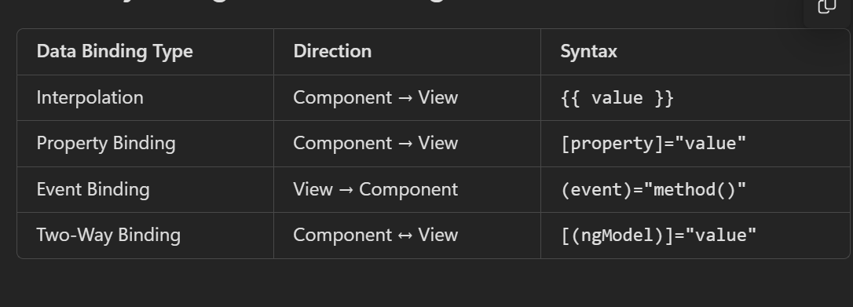

Task 3:
Why do you need Angular? Can you give some advantages of using angular with description.
As web applications become more complex, developers need a framework that helps build dynamic, scalable, and maintainable applications efficiently. Angular provides a structured way to develop modern web applications by offering built-in features such as routing, data binding, dependency injection, form handling, and state management.
Without Angular, developers would need to write large amounts of JavaScript code and manually manage many application functionalities. Angular simplifies this process and improves productivity.
Advantages of Using Angular
1. Component-Based Architecture
2. Two-Way Data Binding
3. Dependency Injection (DI)
4. TypeScript Support
5. Built-In Routing
6. Improved Performance
7. Strong Testing Support
8. Large Community and Google Support

Task 4;
What is Rest API?
REST API (Representational State Transfer Application Programming Interface) is a set of rules and standards that allows different applications to communicate with each other over the internet using the HTTP protocol.
A REST API acts as a bridge between a client (frontend application, mobile app, etc.) and a server (backend application, database, etc.).

Task 5:
Why do we use Rest API?
REST API is used to enable communication between different applications, systems, or services over the internet. It provides a standard way for a client application (Angular, React, Mobile App, etc.) to interact with a backend server.
For example, an Angular application cannot directly access a database. Instead, it sends requests to a REST API, and the API handles the business logic and database operations.

Task 6:
What are single Page Applications?
A Single Page Application (SPA) is a web application that loads a single HTML page initially and dynamically updates the content without reloading the entire webpage whenever the user interacts with the application.
Unlike traditional web applications, SPAs communicate with the server in the background using APIs and update only the required parts of the page.
Task 7:
Explain modules, components and services in Angular.
Angular applications are mainly built using Modules, Components, and Services. These are the core building blocks that help organize and manage an application efficiently.
1. Modules in Angular
A Module is a container that groups related components, directives, pipes, and services together.
Modules help organize the application into logical sections and make the application easier to maintain.
Common Types of Modules
- Root Module (AppModule): Main module of the application.
- Feature Module: Contains functionality for a specific feature.
- Shared Module: Contains reusable components, directives, and pipes.
- Core Module: Contains singleton services used throughout the application.

2. Components in Angular
A Component is the most important building block in Angular.
A component controls a portion of the user interface (UI). Every Angular application consists of one or more components.
A component contains:
- HTML Template (View)
- TypeScript Class (Logic)
- CSS/SCSS (Styling)

3. Services in Angular
A Service is a class used to store business logic, shared data, or functionality that can be used by multiple components.
Instead of writing the same code in different components, we place common functionality inside a service.
Why Do We Use Services?
- Share data between components.
- Handle API calls.
- Implement business logic.
- Improve code reusability.
- Keep components clean and lightweight.

Task 8:
In data binding can you explain Property Binding ,Event Binding, String Interpolation, Two way data binding
1. String Interpolation
- Used to display data from the component in the UI.
- One-way data flow: Component → View.
- Mainly used for displaying text, numbers, and expressions.
2. Property Binding
- Used to set HTML element properties using component data.
- One-way data flow: Component → View.
- Commonly used for attributes like image source, disabled state, and input values.
3. Event Binding
- Used to handle user actions such as clicks, key presses, and form events.
- One-way data flow: View → Component.
- Executes component methods when an event occurs.
4. Two-Way Data Binding
- Used to keep component data and UI data synchronized.
- Two-way data flow: Component ↔ View.
- Any change in the UI updates the component, and any change in the component updates the UI automatically.

Task 9:
What are decorators? Explain types of decorators.
Decorators are special functions in Angular that provide metadata about a class, property, method, or parameter. They tell Angular how a particular class or member should behave.
Types of Decorators in Angular
1. Class Decorators
Used to define the purpose of a class.
Examples:
- @Component → Defines a Component.
- @NgModule → Defines a Module.
- @Injectable → Defines a Service.
- @Directive → Defines a Directive.
- @Pipe → Defines a Pipe.
Purpose: Tell Angular what role a class plays in the application.

2. Property Decorators
Used on class properties.
Examples:
- @Input() → Receives data from a parent component.
- @Output() → Sends data to a parent component.
- @HostBinding() → Binds a property to a host element.
Purpose: Configure and manage component properties.

3. Method Decorators
Used on methods.
Examples:
- @HostListener() → Listens to DOM events on the host element.
Purpose: Respond to events and define method behavior.
4. Parameter Decorators
Used on constructor parameters.
Examples:
- @Inject()
- @Optional()
- @Self()
- @SkipSelf()
Purpose: Control dependency injection behavior.

Task 10:
What are annotations in angular?
Annotations are metadata that provide additional information to Angular about a class and how it should be processed.
They help Angular identify whether a class is a Component, Directive, Module, Service, or other Angular building block.
In modern Angular, the term Decorators is more commonly used, and annotations are generally referred to as decorators.
Common Annotations (Decorators) in Angular
- @Component → Defines a Component.
- @NgModule → Defines a Module.
- @Injectable → Defines a Service.
- @Directive → Defines a Directive.
- @Pipe → Defines a Pipe.

Installation: -

# Install Angular CLI
npm install -g @angular/cli

# Create Project
ng new my-angular-app

# Go to Project
cd my-angular-app

# Run Project
ng serve --open

Task 11:
In the below code snippet what are we doing .. can you explain..

// parent component
import { Component } from '@angular/core';
@Component({
selector: 'app-parent',
template: `
<app-child [childMessage]="parentMessage"></app-child>
`,
styleUrls: ['./parent.component.css']
})
export class ParentComponent{
parentMessage = "message from parent"
constructor() { }
}
// child component
import { Component, Input } from '@angular/core';
@Component({
selector: 'app-child',
template: `Say {{ childMessage }}`,
styleUrls: ['./child.component.css']
})
export class ChildComponent {
@Input() childMessage: string;
constructor() { }
}

This example demonstrates Parent-to-Child Communication in Angular using @Input() and Property Binding.

• This example shows Parent-to-Child Communication in Angular.
• The Parent Component has a variable called parentMessage.
• The value of parentMessage is "message from parent".
• The parent sends this value to the child component using Property Binding.
• The Child Component receives the value using the @Input() decorator.
• The received value is stored in childMessage.
• The child component displays childMessage on the screen using interpolation.

Task 12:
Can you create a typescript class with a constructor and a function.
class Employee {
name: string;
age: number;

// Constructor
constructor(name: string, age: number) {
this.name = name;
this.age = age;
}

// Function
displayDetails(): void {
console.log(`Name: ${this.name}, Age: ${this.age}`);
}
}

// Create an object
const employee1 = new Employee("Pavan", 30);

// Call the function
employee1.displayDetails();

Task 13:
There is something called eager loading. What do you mean by eager and lazy loading?
In Angular, Eager Loading and Lazy Loading are techniques used to load modules in an application.
Eager loading means a module is loaded immediately when the application starts.
Lazy loading means a module is loaded only when the user navigates to it.

Task 14:
What is an observable response?
In Angular (and RxJS), an Observable is an object that emits data over time. An observable response is the data that an Observable emits when an asynchronous operation, such as an HTTP request, completes.

Task 15:
What is the flow of your Angular project.. Explain with an ex.
The flow of an Angular application describes how Angular starts, loads components, fetches data, and displays it to the user.
• Application starts from the entry point (main.ts).
• Angular bootstraps the root component using bootstrapApplication().
• The root component loads and becomes the main container of the application.
• Angular Router checks the URL and loads the appropriate page/component.
• The component initializes and executes its lifecycle methods.
• The component calls a service whenever data is required.
• The service communicates with the backend/API through HTTP requests.
• The backend processes the request and sends back a response.
• The response is received as an Observable.
• The component subscribes to the Observable and gets the data.
• Angular updates the component's data model.
• Data binding reflects the updated data in the UI automatically.
• Change Detection runs and refreshes the view wherever data has changed.
• User interactions (clicks, form submissions, etc.) trigger events.
• The cycle repeats as components interact with services and APIs.

